Inquiry Project Plan
Inquiry Title: |  | Time Frame |  | Inquiry Approach:
Name: |  | Subject(s): |  | Grade(s):

Inquiry Project Rationale & Overview
Why does this topic matter to students?
How does this project incorporate the inquiry cycle?

Key Questions For Inquiry About the Topic of Study
Core Question | Supporting Questions

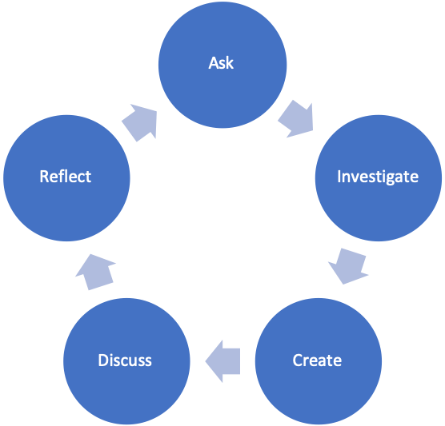

Inquiry Approach/Style and Rationale

Core Principles of Effective Teaching (Sharon Friesen)
Core Principle 1: Effective teaching practice begins with the thoughtful and intentional design of learning that engages students intellectually and academically.
**How is the inquiry focused on building disciplinary knowledge and understandings?
Core Principle 2: The work that students are asked to undertake is worthy of their time and attention, is personally relevant, and deeply connected to the world in which they live.
*What makes this inquiry valuable, meaningful, and “alive” for the students and teachers?
Core Principle 3: Assessment practices are clearly focused on improving student learning and guiding teaching decisions and actions.
*How do I define learning and success in this inquiry? How is learning expressed and articulated in peer, self and teacher assessments?
Core Principle 4: Teachers foster a variety of interdependent relationships in classrooms that promote learning and create a strong culture around learning.
*How do I connect students with each other, with experts in the field, with larger communities and nature, and across disciplines?
Core Principle 5: Teachers improve their practice in the company of peers.
*How do I reflect on the inquiry together, and/or collaborate with others?

BC Curriculum Core Competencies
Communication | Thinking | Personal & Social

BC Curriculum Big Ideas (STUDENTS UNDERSTAND)

BC Curriculum Learning Standards
(STUDENTS DO) | (STUDENTS KNOW)
Learning Standards - Curricular Competencies | Learning Standards - Content

Indigenous Connections/ First Peoples Principles of Learning
How will I incorporate Indigenous knowledge and principles of learning?

Respectful Relations
How will I invite students of all backgrounds, interests and skills into the inquiry?

Project Overview
Time Estimate |  | Teacher and Student Activities | Assessment Activities
Ask

Investigate

Create

Discuss
Reflect

Materials and Resources (use APA citation format)

Organizational Strategies (Optional)

Proactive, Positive Classroom Learning Environment Strategies (Optional)

Extensions

Reflections (to be completed after Project Completion)
What did I learn about Inquiry Based Pedagogy?
What challenges and successes did I experience?
What would I adapt for next time?
What questions do I still have about Inquiry Based Pedagogy?

